Abellera, Joshua Beaver Q,

Meneses, James Joash

ECE 2112

**Machine Problem 1**

Screenshots(Matlab)

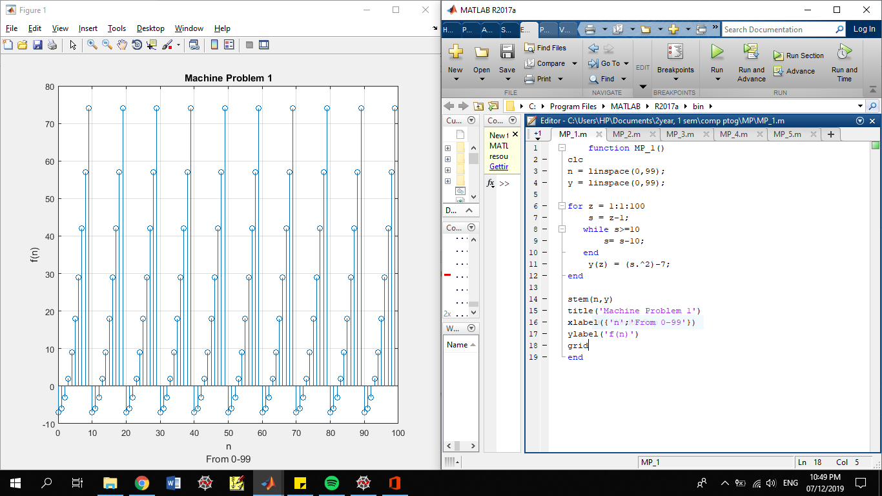

Observation:

In this graph, we have observed that there are only 9 y-components on the whole graph, due to the 2nd piecewise function. This means that the graph has only has a range of {-7, -6, -3,2,9,18,29,42,57,74}. The graph is also a series of a left side of a quadratic function opening upward.